 | 10.1.13 Editors - Compositor Editor - Header - Add Menu - Transform
Table of content
Detailed table of content 1
Add menu - Transform 5
Rotate 5
Scale 6
Transform 7
Translate 9
Corner Pin 10
Crop 11
Displace 12
Flip 13
Map UV 13
Lens Distortion 15
Movie Distortion 16

Detailed table of content
Detailed table of content
Detailed table of content 1
Add menu - Transform 5
Rotate 5
Inputs 5
Image 5
Angle 5
Sampling Subpanel 5
Interpolation 5
Nearest 5
Bilinear 5
Bicubic 5
Anisotropic 6
Extension X 6
Extension Y 6
Outputs 6
Image 6
Scale 6
Inputs 6
Image 6
Type 6
Relative 6
Absolute 6
Scene Size 6
Render Size 6
Stretch, Fit, Crop 6
X, Y 7
Sampling Subpanel 7
Interpolation 7
Nearest 7
Bilinear 7
Bicubic 7
Anisotropic 7
Extension X 7
Extension Y 7
Outputs 7
Image 7
Transform 7
Inputs 8
Image 8
X, Y 8
Angle 8
Scale 8
Sampling Subpanel 8
Interpolation 8
Nearest 8
Bilinear 8
Bicubic 8
Anisotropic 8
Extension X 8
Extension Y 8
Outputs 9
Image 9
Translate 9
Inputs 9
Image 9
X, Y 9
Sampling Subpanel 9
Interpolation 9
Nearest 9
Bilinear 9
Bicubic 9
Anisotropic 9
Extension X 9
Extension Y 10
Outputs 10
Image 10
Corner Pin 10
Inputs 10
Image 10
Corners ( Upper left, Upper Right, etc. ) 10
Sampling Subpanel 10
Interpolation 10
Nearest 10
Bilinear 10
Bicubic 10
Anisotropic 11
Extension X 11
Extension Y 11
Outputs 11
Image 11
Plane 11
Crop 11
Inputs 11
Image 11
X / Y 11
Width / Height 11
Alpha Crop 11
Outputs 11
Image 11
Displace 12
Inputs 12
Image 12
Displacement 12
Scale X, Y 12
Sampling Subpanel 12
Interpolation 12
Nearest 12
Bilinear 12
Bicubic 12
Anisotropic 12
Extension X 12
Extension Y 13
Outputs 13
Image 13
Flip 13
Inputs 13
Image 13
Flip X 13
Flip Y 13
Outputs 13
Image 13
Map UV 13
Inputs 14
Image 14
UV 14
Sampling Subpanel 14
Interpolation 14
Nearest 14
Bilinear 14
Bicubic 14
Anisotropic 14
Extension X 14
Extension Y 14
Outputs 14
Image 14
Lens Distortion 15
Inputs 15
Image 15
Type 15
Type Radial 15
Distortion 15
Dispersion 15
Jitter 15
Fit 15
Type Radial 15
Dispersion 15
Outputs 15
Image 15
Movie Distortion 16
Distortion vs Undistortion 16
Calculating Distortion 16
Inputs 16
Image 16
Type 16
Undistort 16
Distort 16
Movie Clip 16
Outputs 17
Image 17

Add menu - Transform
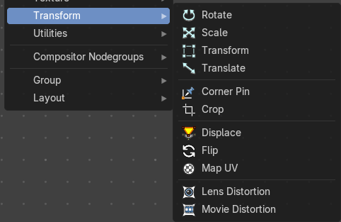
These nodes distort the image in some fashion. They work either on the whole image, or by using a mask to vary the effect over the image.

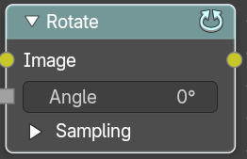
Rotate
This node rotates an image.

Inputs

Image
Standard image input.

Angle
Rotation angle in degree. Positive values rotate clockwise and negative ones counterclockwise.

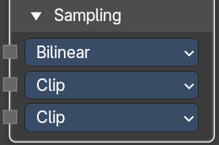
Sampling Subpanel

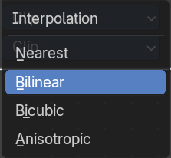
Interpolation
The interpolation mode.

Nearest
No interpolation. This method uses the nearest neighboring pixel.

Bilinear
Simple interpolation between adjacent pixels.

Bicubic
Highest quality interpolation.

Anisotropic
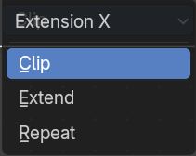
Anisotropic interpolation.

Extension X
The extension mode applied to the X axis.

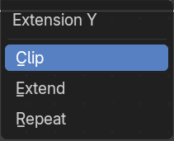
Extension Y
The extension mode applied to the Y axis.

Outputs

Image
Standard image output.

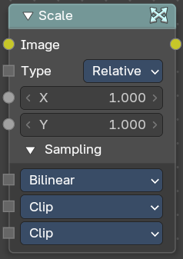
Scale
The Scale node scales the size of an image.

Inputs

Image
Standard image input.

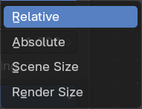
Type
Coordinate Space to scale relative to.

Relative
Percentage values relative to the dimensions of the image input.

Absolute
Size of an image by using absolute pixel values.

Scene Size
Sizes an image to the size of the final render resolution for the scene. For example, rendering a scene at the standard 1080p resolution but setting the render percentage at 50%, will produce a 1080p image with the scene scaled down 50% and leaving the rest of the image as alpha.

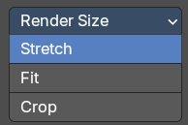
Render Size
Image dimensions set in the Render panel.

Stretch, Fit, Crop
Render Size setting. Stretch distorts the image so that it fits into the render size. Fit scales the image until the bigger axis “fits” into the render size. Crop cuts the image so that it is the same aspect ratio as the render size.

X, Y
Scale in the axis directions, only available if Space is set to Relative or Absolute.

Sampling Subpanel

Interpolation
The interpolation mode.

Nearest
No interpolation. This method uses the nearest neighboring pixel.

Bilinear
Simple interpolation between adjacent pixels.

Bicubic
Highest quality interpolation.

Anisotropic
Anisotropic interpolation.

Extension X
The extension mode applied to the X axis.

Extension Y
The extension mode applied to the Y axis.

Outputs

Image
Standard image output.

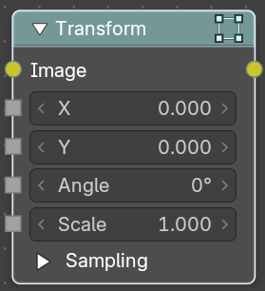
Transform
The Transform node combines the functionality of three other nodes: Scale, translate, and rotate nodes.

Inputs

Image
Standard image input.

X, Y
Used to move the input image horizontally and vertically.

Angle
Used to rotate an image around its center. Positive values rotate counter-clockwise and negative ones clockwise.

Scale
Used to resize the image. The scaling is relative, meaning a value of 0.5 gives half the size and a value of 2.0 gives twice the size of the original image.

Sampling Subpanel

Interpolation
The interpolation mode.

Nearest
No interpolation. This method uses the nearest neighboring pixel.

Bilinear
Simple interpolation between adjacent pixels.

Bicubic
Highest quality interpolation.

Anisotropic
Anisotropic interpolation.

Extension X
The extension mode applied to the X axis.

Extension Y
The extension mode applied to the Y axis.

Outputs

Image
Standard image output.

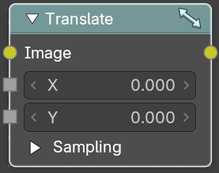
Translate
The Translate node moves an image.
Could also be used to add a 2D camera shake.

Inputs

Image
Standard image input.

X, Y
Used to move the input image horizontally and vertically.

Sampling Subpanel

Interpolation
The interpolation mode.

Nearest
No interpolation. This method uses the nearest neighboring pixel.

Bilinear
Simple interpolation between adjacent pixels.

Bicubic
Highest quality interpolation.

Anisotropic
Anisotropic interpolation.

Extension X
The extension mode applied to the X axis.

Extension Y
The extension mode applied to the Y axis.

Outputs

Image
Standard image output.

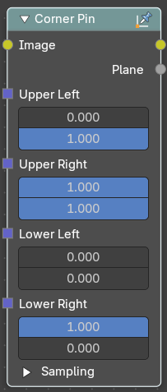
Corner Pin
The Corner Pin node uses explicit corner values for a plane warp transformation. It works like the Plane Track Deform node, but without using “plane track” data from the Movie Clip Editor.

Inputs

Image
Standard image input.

Corners ( Upper left, Upper Right, etc. )
Four vector inputs to define the plane warping. (Z component of vector inputs is ignored.)

Sampling Subpanel

Interpolation
The interpolation mode.

Nearest
No interpolation. This method uses the nearest neighboring pixel.

Bilinear
Simple interpolation between adjacent pixels.

Bicubic
Highest quality interpolation.

Anisotropic
Anisotropic interpolation.

Extension X
The extension mode applied to the X axis.

Extension Y
The extension mode applied to the Y axis.

Outputs

Image
Standard image output. (The image after distorting.)

Plane
A black-and-white alpha mask of the plane.

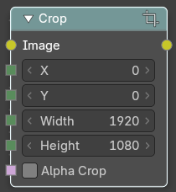
Crop
The Crop Node takes an input image and crops it to a selected region.

Inputs

Image
Standard image input.

X / Y
X and Y position of the origin.

Width / Height
The size of the crop area.

Alpha Crop
Make the outer areas of the area transparent instead of cropping the image.

Outputs

Image
Standard image output.

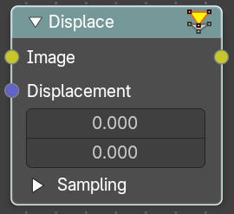
Displace
The Displace Node displaces the pixel position based on an input vector.
This node could be used to model phenomena, like hot air distortion, refraction's of uneven glass or for surreal video effects.

Inputs

Image
Standard image input.

Displacement
Input of the displacement map. If the a color output is implicitly converted in the vector input, the first channel (red) value determines displacement along X axis. The second channel (green) the displacement along Y axis. If the input is a greyscale image, where both the channel values are equal, the input image will be displaced equally in both X and Y directions.

Scale X, Y
Separate scaling of the vector input in X and Y direction. Acting as multipliers by increasing or decreasing the strength of the displacement along their respective axes.

Sampling Subpanel

Interpolation
The interpolation mode.

Nearest
No interpolation. This method uses the nearest neighboring pixel.

Bilinear
Simple interpolation between adjacent pixels.

Bicubic
Highest quality interpolation.

Anisotropic
Anisotropic interpolation.

Extension X
The extension mode applied to the X axis.

Extension Y
The extension mode applied to the Y axis.

Outputs

Image
Standard image output.

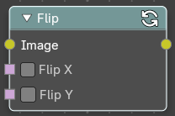
Flip
This node flips an image at defined axis.
You can use this node to just flip or use it as a part of mirror setting. Mix half of the image to be mirrored with its flipped version to produce mirrored image.

Inputs

Image
Standard image input.

Flip X
Flip the image along the X axis.

Flip Y
Flip the image along the Y axis.

Outputs

Image
Standard image output.

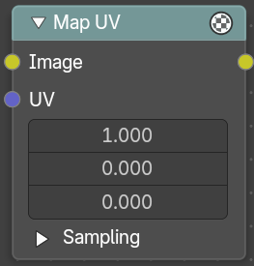
Map UV
With the Map UV node objects can be “re-textured” after they have been rendered.
To apply a texture to individual enumerated objects the ID Mask Node could be used.

Inputs

Image
The new 2D texture.

UV
The input for UV render pass. See Cycles render passes.
Hint. To store the UV pass a multi-layer OpenEXR format could be used.

Sampling Subpanel

Interpolation
The interpolation mode.

Nearest
No interpolation. This method uses the nearest neighboring pixel.

Bilinear
Simple interpolation between adjacent pixels.

Bicubic
Highest quality interpolation.

Anisotropic
Anisotropic interpolation.

Extension X
The extension mode applied to the X axis.

Extension Y
The extension mode applied to the Y axis.

Outputs

Image
The resulting image is the input image texture distorted to match the UV coordinates. That image can then be overlay mixed with the original image to paint the texture on top of the original. Adjust alpha and the mix factor to control how much the new texture overlays the old.
Hint. When painting the new texture, it helps to have the UV maps for the original objects in the scene, it is recommended to keep those UV texture outlines around even, when shooting is done.

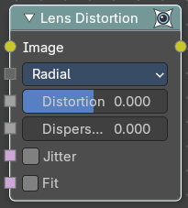
Lens Distortion
Use this node to simulate distortions that real camera lenses produce.

Inputs

Image
Standard image input.

Type
The lens distortion type.

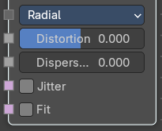
Type Radial

Distortion
This creates a bulging or pinching effect from the center of the image.

Dispersion
This simulates chromatic aberrations, where different wavelengths of light refract slightly differently, creating a rainbow colored fringe.

Jitter
Adds jitter to the distortion. Faster, but noisier.

Fit
Scales image so black areas are not visible. Only works for positive distortion.

Type Radial

Dispersion
This simulates chromatic aberrations, where different wavelengths of light refract slightly differently, creating a rainbow colored fringe.

Outputs

Image
Standard image output.

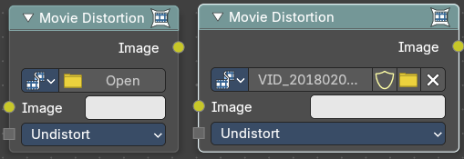
Movie Distortion
In the real world, all camera lenses produce some or the other sort of lens distortion. But, whatever we render has got no distortion. So, this node helps in removing distortion from movies or adding distortion to render to make our render blend in with the movie clip.
Usually, it is used while motion tracking.

Distortion vs Undistortion
Although, both, distortion of render and undistortion of movie clip are possible, and produce similar results, there is a difference between these two methods.
There are two kinds of lens distortion possible and, in simple terms, they can be said as:
When the movie clip is bulging out.
When the movie clip is bulging in.
For the first case, it is recommended to distort the render and leave the movie clip as it is, because, undistorting the movie clip will require extra pixel information, which is not available to Blender. Similarly, in the second case, it is recommended to undistort the movie clip and leave the render as it is, because, distorting the render will require those extra unavailable pixels. Doing the wrong method in the wrong case can create weird results around the edges, such as in the image shown.

Calculating Distortion
Before using this node, one has to calculate the lens distortion of the clip. This can be done by adjusting K1, K2 and K3 values in Movie Clip Editor > Properties ? Lens. For more information on how to edit those values, check this out.

Inputs

Image
Standard image input.

Type

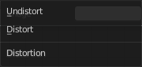
Undistort
Used to undistort the image received, and is usually used for the raw distorted movie clip.

Distort
Used to distort the image received, and is usually used for rendered images.

Movie Clip
Used to select the movie clip whose distortion is to be used. This can be useful if more than one movie clips are present, each having a different distortion setting. For controls see Data-Block Menu.

Outputs

Image
Standard image output.

